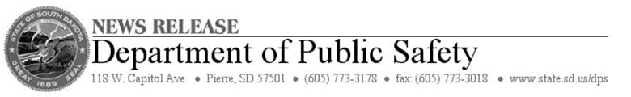

**FOR IMMEDIATE RELEASE**: Tuesday, July 15, 2014  
**CONTACT:** Terry Woster at 605-773-3178

**Governor Daugaard Urges Flood, Tornado Victims to Contact SBA**

PIERRE, S.D. – Gov. Dennis Daugaard today urged South Dakotans whose homes or businesses suffered tornado or flood damage to take advantage of low-interest disaster loans available from the Small Business Administration (SBA).

Gov. Daugaard requested SBA assistance on Friday, July 11. SBA issued a disaster declaration late Monday for South Dakota homes and businesses impacted by storms, flooding and tornadoes during the period June 13-20.

“This is very good news for our citizens and businesses,’’ the Governor said. “The availability of low-interest loans is an important step toward recovery from the flooding and tornadoes. I very much appreciate the quick response from SBA to my request for this disaster declaration.’’

The disaster declaration makes SBA low-interest loans available in the primary counties of Jerauld and Lincoln, as well as the neighboring, or contiguous, counties of Buffalo, Hand, Beadle, Sanborn, Aurora, Brule, Minnehaha, Turner, Clay and Union counties.

Residents impacted by the tornadoes or flooding may visit SBA outreach centers in:

**Jerauld County**: Jerauld County Ag Building, 604 2nd St. NE, Wessington Springs. Opens Wednesday, July 16, at noon and then is in operation Monday through Friday from 9 a.m. to 6 p.m. The center closes on Thursday, July 31 at 1 p.m.

**Lincoln County:** Canton High School, 800 N. Main St., Canton. Opens Wednesday, July 16, at 9 a.m., and then is in operation Wednesdays and Thursdays from 9 a.m. to 6 p.m. and Fridays from 9 a.m. to 4 p.m. The center closes on Thursday, July 31, at 6 p.m.

**Union County:** Elk Point City Hall, 106 W. Pleasant St., Elk Point. Opens Monday, July 21 at 9 a.m. and then is in operation Mondays from 9 a.m. to 6 p.m. and Tuesdays from 9 a.m. to 4 p.m. The center closes on Tuesday, July 29, at 4 p.m.

Disaster loans up to $200,000 are available to homeowners to repair or replace damaged or destroyed real estate. Homeowners and renters are eligible for up to $40,000 to repair or replace damaged or destroyed personal property. Businesses may borrow up to $2 million to repair or replace damaged or destroyed real estate, machinery and equipment, inventory and other business assets, according to SBA.

While the SBA assistance is available to homeowners and businesses impacted by the storms, teams of teams of state, federal and local representatives are in the preliminary damage assessment stage to determine the impact of the series of storms on public infrastructure.

The teams began a preliminary damage assessment of 12 counties and the Standing Rock Indian Reservation today (Monday). Damages documented during the assessments will be provided to the Governor to support a possible request to FEMA for the Public Assistance Program to provide federal funding for eligible damages to roads, bridges, culverts and other public infrastructure.