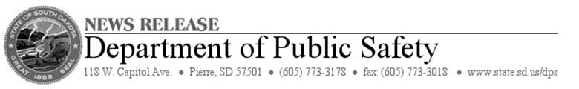

**FOR IMMEDIATE RELEASE**: Monday, July 28, 2014

**CONTACT:** Terry Woster at 605-773-3178

**Disaster Declaration Approved for June Flooding, Tornadoes**

PIERRE, S.D. –Gov. Dennis Daugaard announced today that 12 South Dakota counties**,** including the Standing Rock Indian Reservation, will receive federal financial help to recover from a series of June storms that produced damaging tornadoes and flooding.

The public assistance is made available through a Presidential Disaster Declarationsigned Monday by President Obama.

Preliminary estimates show more than $6.8 million in damages to public and private nonprofit property. Costs included debris removal and repairs to roads, bridges and culverts and other public infrastructure.

“We are gratified by the quick and positive response to our request for a disaster declaration,’’ Gov. Daugaard said. “Receiving the presidential declaration will help our impacted communities recover as quickly as possible from the tornadoes and flooding.’’

Counties eligible for assistance are Butte, Clay, Corson, Dewey, Hanson, Jerauld, Lincoln, Minnehaha, Perkins, Turner, Union and Ziebach, including the Standing Rock Indian Reservation within Corson County. A disaster declaration authorizes the federal government to provide recovery assistance for up to 75 percent of the eligible costs.