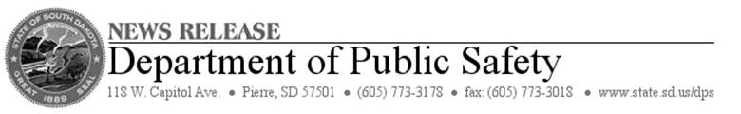

**FOR IMMEDIATE RELEASE:** Monday, July 28, 2014  
**CONTACT:** Terry Woster at 605-773-3178

**SBA Disaster Loan Centers in South Dakota to Close This Week**

PIERRE, S.D. – Small Business Administration outreach centers set up to help victims of flooding and tornadoes will close this week in three South Dakota cities.

The SBA issued a disaster declaration earlier this month for South Dakota homes and businesses impacted by storms, flooding and tornadoes during the period June 13-20.

The disaster declaration made SBA low-interest loans available in the primary counties of Jerauld and Lincoln, as well as the neighboring, or contiguous, counties of Buffalo, Hand, Beadle, Sanborn, Aurora, Brule, Minnehaha, Turner, Clay and Union counties.

The schedule of closing for the centers is:

**Union County:** Elk Point City Hall, 106 W. Pleasant St., Elk Point. Closing on Tuesday, July 29, at 4 p.m.

**Jerauld County**: Jerauld County Ag Building, 604 2nd St. NE, Wessington Springs. Closing on Thursday, July 31, at 1 p.m.

**Lincoln County:** Canton High School, 800 N. Main St., Canton. Closing on Thursday, July 31, at 6 p.m.