**The Union County State’s Attorney, Jerry A. Miller is reposting this notice as a press release on 11/27/13. Lind is also wanted on new felony charges in Union County in addition to this warrant.**

**STATE OF SOUTH DAKOTA**

**BOARD OF PARDONS AND PAROLES**

**STATE OF SOUTH DAKOTA** **Warrant #**  **1308260707**

**Plaintiff** **WARRANT OF ARREST FOR**

**Vs** **ALLEGED VIOLATION OF PAROLE**

**LIND, ARTHUR** 0000020117

**DOB:**  10/03/1970

**Defendant**

AMENDED WARRANT REPORT

     It appearing to our satisfaction that LIND, ARTHUR P has violated the provision of SDCL 24-15-21 / 24-15A-27, and that the purpose and objects of the parole heretofore granted to him/her are not subserved, it is:

     Ordered that by this writ the Warden of Penitentiary for the State of South Dakota, and all Sheriffs, Constables, Coroners, Parole Officers, Parole Agents, or other persons having jurisdiction in and for the State of South Dakota, or any other state, are ordered and directed to arrest the said LIND, ARTHUR to hold him/her for hearing before an independent hearing officer of the State of South Dakota on charges of alleged violation of his/her supervision agreement. By this Warrant, his/her parole status will terminate as of the date of this Warrant. **Original WARRANT issue date: 8/16/13** Dated this 11/07/2013.

**ABSCONDER**

**BOARD OF PARDONS AND PAROLES**

**STATE OF SOUTH DAKOTA**

**South Dakota Warrant** #:1308260707 **Date Issued**:  26-AUG-13

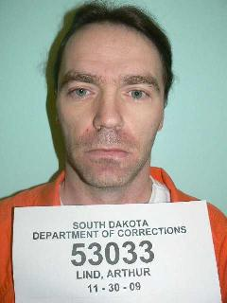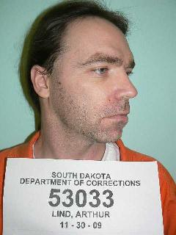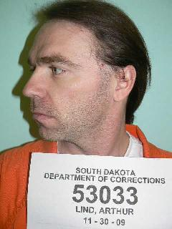

**FRONT RIGHT**  **LEFT**

**NAME:** LIND, ARTHUR P **DOC#**: 0000020117 **BOOKING ID**#:  2009-025849

**ALIASES**: **PHYSICAL DESCRIPTION:**

**DOB:** 10/03/1970     **Eye Color**:     Blue

**Gender:**Male        **Hair Color:**Brown

**Height:**6' 0"**Race:**             White

**Weight:**150

**FBI NUMBER #:** 531902KA7

**RELEASED TO PAROLE:** 22-JUN-11

**CURRENT OFFENSE:** DWI 5TH

FAILURE TO APPEAR

**SENTENCE TERMS:** 5Y 0M 0D

2Y 0M 0D

2Y 0M 0D

**COURT OF CONVICTION:** Minnehaha County Court

**OFFENDER PLACE OF BIRTH:** SIOUX FALLS, SD USA

**LAST KNOWN ADDRESS:**  30274    481st   Alcohol, SD

**MARKS, SCARS, & TATOOS:** SCARS: NONE TATTOOS: LFT UPPERARM-SK

ULL W/ SUNGLASSES, HEAD BAND.LFT UPPER BACK-SKULL W/HAIR. RT UPPERLEG- ACE CARD /SKULL, SCYTHE.....

**VEHICLE INFORMATION:**     

**GANG AFFILIATION:**

**PAROLE AGENT:** MARK KATTERHAGEN**CELL PHONE:** (605)661-8594

**COMMENTS: (possible whereabouts or affiliations)**

- 30 -