Union County Fair Board
209 E. Main Street, Suite 120
Elk Point, SD 57025
605-356-2321
union.county@sdstate.edu

March 30, 2014

The regular monthly meeting of the Union County Fair Board will be held Wednesday, April 8, 2015 at 7:00 p.m. at the Fairgrounds in Alcester.

AGENDA

- Call to Order

- Reading & Approval of Minutes

- Treasurers Report – Dan & Janet

- Unfinished/Old Business

- Ranch Rodeo (Cancelled) New Event Needed
- Tractor Pull Help, Announcer, etc
- Supper
- Hoop, Rabbit Barn & Main Exhibit Building (Repairs)

- New Business

- Committee Lists
- Final Fair Schedule
- Supper (Meat, Supplies, etc)
- Building Walk Through
- 85th Anniversary Banner

- Other Business

- Set Next Meeting Date

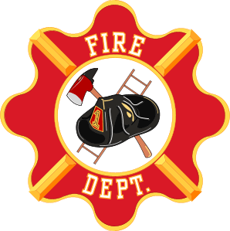
EMT & Firemen
Appreciation

Union County Fairboard & 4-H Members
Union County Fair—August 1-4, 2013
Community Supper-August 2nd@5:00 pm
Fairgrounds, Alcester, SD
EMT & Firemen
Appreciation

Union County Fairboard & 4-H Members
Union County Fair—August 1-4, 2013
Community Supper-August 2nd@5:00 pm
Fairgrounds, Alcester, SD
- Adjournment

