**The Union County State’s Attorney, Jerry A. Miller is reposting this notice as a press release on 11/27/13.**

**STATE OF SOUTH DAKOTA**

**BOARD OF PARDONS AND PAROLES**

**STATE OF SOUTH DAKOTA** **Warrant #**  **1311251140**

**Plaintiff** **WARRANT OF ARREST FOR**

**Vs** **ALLEGED VIOLATION OF PAROLE**

**GRANT, CARA** 0000024210

**DOB:**  10/20/1964

**Defendant**

     It appearing to our satisfaction that GRANT, CARA  has violated the provision of SDCL 24-15-21 / 24-15A-27, and that the purpose and objects of the parole heretofore granted to him/her are not subserved, it is:

     Ordered that by this writ the Warden of Penitentiary for the State of South Dakota, and all Sheriffs, Constables, Coroners, Parole Officers, Parole Agents, or other persons having jurisdiction in and for the State of South Dakota, or any other state, are ordered and directed to arrest the said GRANT, CARA to hold him/her for hearing before an independent hearing officer of the State of South Dakota on charges of alleged violation of his/her supervision agreement. By this Warrant, his/her parole status will terminate as of the date of this Warrant. Dated this 11/25/2013.

**ABSCONDER**

**BOARD OF PARDONS AND PAROLES**

**STATE OF SOUTH DAKOTA**

**South Dakota Warrant** #:1311251140                       **Date Issued**:  25-NOV-13

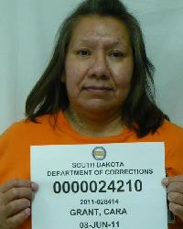 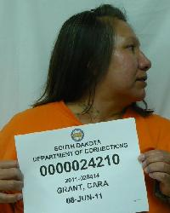 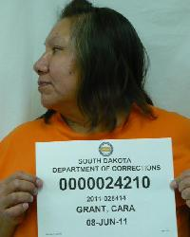

**FRONT**                                       **RIGHT**                                          **LEFT**

**NAME:** GRANT, CARA                   **DOC#**: 0000024210          **BOOKING ID**#:  2011-028414

**ALIASES**:                                                                                  **PHYSICAL DESCRIPTION:**

MERRICK, CARA **DOB:** 10/20/1964     **Eye Color**:     Brown

ROBINSON, CARA**Gender:**Female        **Hair Color:** Brown

**Height:** 5' 6"**Race:**   Native American

**Weight:**260

**FBI NUMBER #:** 415046EAD

**RELEASED TO PAROLE:** 05-NOV-13

**CURRENT OFFENSE:** FORGERY

**SENTENCE TERMS:** 5Y 0M 0D

0Y 3M 0D

**COURT OF CONVICTION:** Union County Court

**OFFENDER PLACE OF BIRTH:** WINNEBAGO, NE USA

**LAST KNOWN ADDRESS:**  4000 S. West Avenue   SIOUX FALLS, SD 57103

**MARKS, SCARS, & TATOOS:** SCARS: BOTH KNEE'S, RT BICEP, GALLBLADDER SURGERY, C

SECTION,SURGERY ON RT ANKLE.  TATTOOS: RT SIDE NECK-FRED, RT BICEP-5 FEATHERS.

LFT WRIST-"ROBIN".LFT THUMB-"C",HEART. LFT FINGERS-J M R/ P O N C E, DOT ON

EACH FINGER.

**VEHICLE INFORMATION:**      

**GANG AFFILIATION:**

**PAROLE AGENT:** KELSEY VEURINK**CELL PHONE:** (605)941-9183

**COMMENTS: (possible whereabouts or affiliations)**

- 30 -