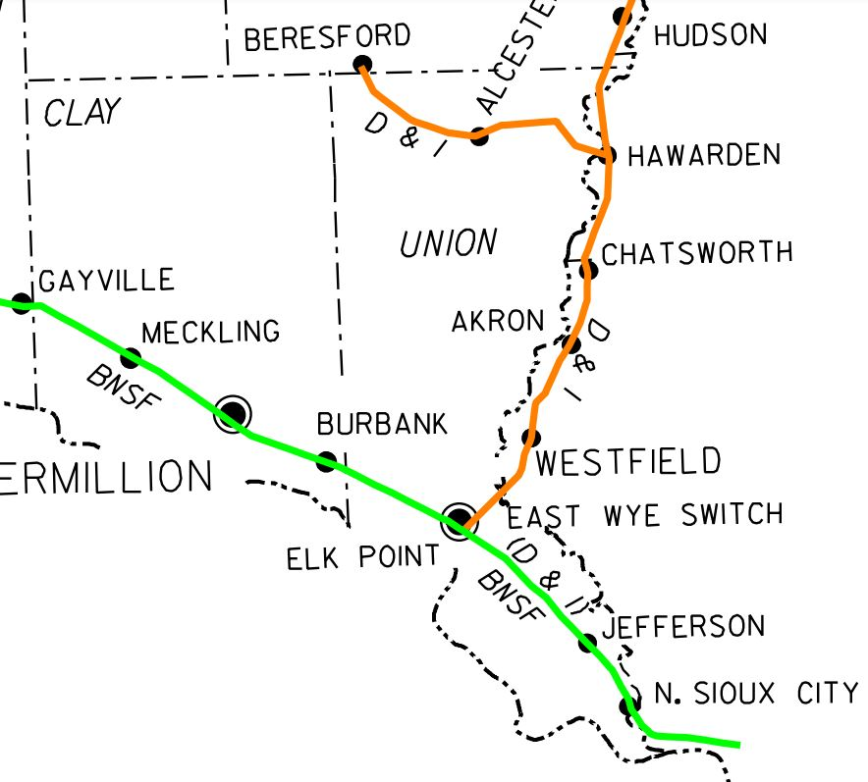

Burlington Northern Santa Fe “BNSF”
D&I Railroad
Burlington Northern Santa Fe “BNSF” Contacts:
Emergencies 1-800-832-5452 option 1
Report Trespasser or Criminal Activity 1-800-832-5452 option 3
D&I Railroad Contacts:
1-605-334-5000
1-800-843-7992

